|  |
| --- |
|  |
| 新概念 3册 |
| Lesson8 **A famous monastery** |

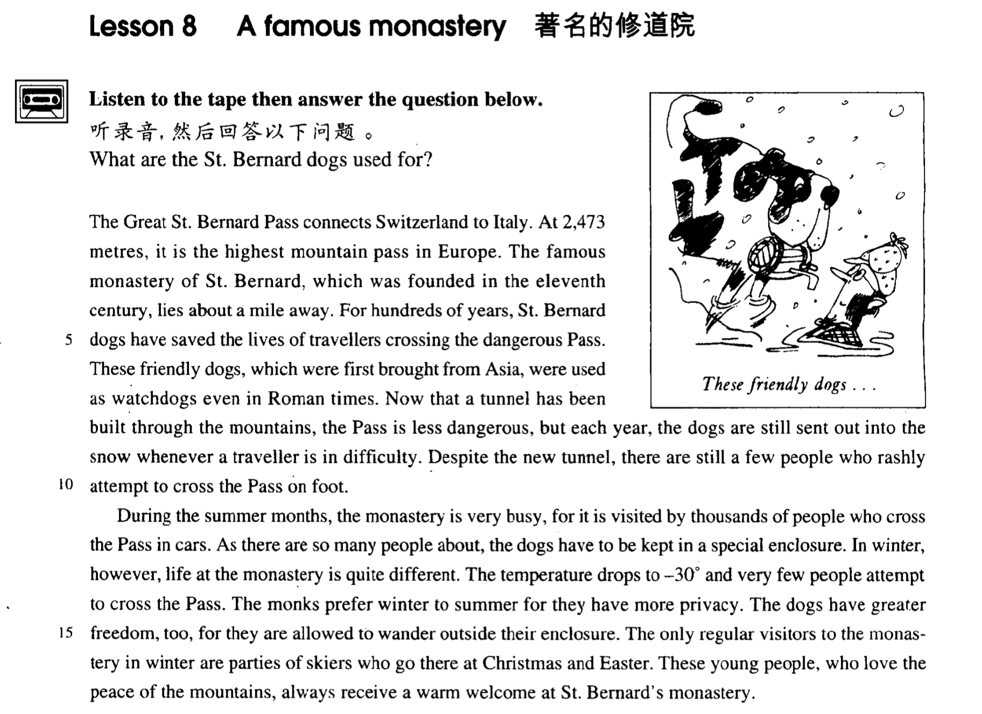

课文

The Great St. Bernard Pass connects Switzerland to Italy.

圣伯纳德大山口连接着瑞士与意大利，

At 2,473 metres, it is the highest mountain pass in Europe.

海拔2,473O米，是欧洲最高的山口。

The famous monastery of St. Bernard, which was founded in the 11th century, lies about a mile away.

11世纪建造的著名的圣伯纳德修道院位于离山口1英里远的地方。

For hundreds of years, St. Bernard dogs have saved the lives of travellers crossing the dangerous Pass.

几百年来，圣伯纳德修道院驯养狗拯救了许多翻越这道山口的旅游者的生命。

These friendly dogs, which were first brought from Asia, were used as watchdogs even in Roman times.

那些最先从亚洲引进的狗，待人友好，早在罗马时代就给人当看门狗了。

Now that a tunnel has been built through the mountains, the Pass is less dangerous,

如今由于山里开挖了隧道，翻越山口已不那么危险了。

but each year, the dogs are still sent out into the snow whenever a traveller is in difficulty.

但每年还要派狗到雪山地里去帮助那些遇到困难的旅游者，

Despite the new tunnel, there are still a few people who rashly attempt to cross the Pass on foot.

尽管修通了隧道，但仍有一些人想冒险徒步跨越圣伯纳德山口。

During the summer months, the monastery is very busy, for it is visited by thousands of people who cross the Pass in cars.

夏天的几个月里，修道院十分忙碌，因为有成千上万的人驾车通过山口，顺道来修道院参观。

As there are so many people about, the dogs have to be kept in a special enclosure.

由于来人太多，狗被关在专门的围栏里。

In winter, however, life at the monastery is quite different.

然而到了冬天，修道院里的生活则是另一番景象。

The temperature drops to -30° and very few people attempt to cross the Pass.

气温下降到零下30度，试图跨越山口的人寥寥无几。

The monks prefer winter to summer for they have more privacy.

修道士们喜欢冬天，而不太喜欢夏天。

The dogs have greater freedom, too, for they are allowed to wander outside their enclosure.

因为在冬天，他们可以更多地过无人打扰的生活。

The only regular visitors to the monastery in winter are parties of skiers who go there at Christmas and Easter.

狗也比较自由，被放出围栏，四处遛达。冬天常来修道院参观的只有一批批滑雪者。

These young people, who love the peace of the mountains, always receive a warm welcome at St. Bernard's monastery.

他们在圣诞节或复活节到那儿去。这些热爱高山清静环境的年轻人每年都受到圣伯纳德道院的热烈欢迎。

词汇讲解

* **monastery** ['mɒnəstri] 【英】/ ['mɑ:nəsteri] 【美】 n. 修道院

monastery ***n.*** 修道院；僧侣 （基督教）

temple ***n.*** 庙宇；寺院；神殿；太阳穴 （基督教之外）

mosque ***n.*** 清真寺

monk ***n.*** 僧侣，修道士；和尚

nun ***n.*** 修女，尼姑

nunnery （***n.*** 尼姑庵；女修道院）/ convent （***n.*** 女修道院）

**church *n.*** 教堂；礼拜；教派

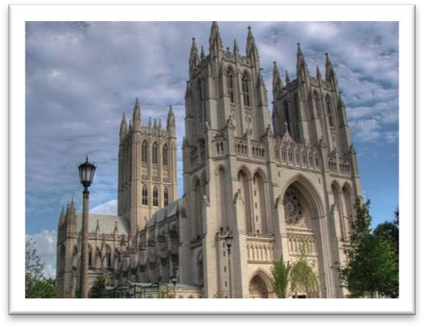

**cathedral *n.*** 大教堂，（主教教堂）



* St. Bernard [seɪnt-bə:'nɑ:d] 圣伯纳德（地名）

St. saint ***n.*** 圣人；圣徒；道德崇高的人

St. Andrew’s Road

St. Paul’s Cathedral

St. Valentine’s Day 情人节

* **rashly** ['ræʃlɪ] ***adv.*** 轻率地；鲁莽地；无见识地

**rash *adj.*** 轻率的；鲁莽的；不顾后果的

* a rash decision
* Don’t make rash promises.

**reckless *adj.*** 鲁莽的，不顾后果的；粗心大意的 （不顾可能出现风险）

* He was fined $100 for reckless driving.

**impulsive** ***adj.*** 冲动的；受感情驱使的；任性的 (头脑发热的，不计后果的)

**impulse *n.*** 冲动；

* She's so impulsive—she saw the house for the first time and said she'd buy it **straight away（立即、立刻）**.
* **enclosure** [ɪn'kləʊʒə(r)] n. 围场，圈地

圈地运动



**enclose** ***vt.*** 围绕；装入；放入封套 （包围）

**be enclosed by …** 被包围

* The garden **was completely enclosed by** a high wall.

**be surrounded by ...** 被包围

* She said that she wanted to die **surrounded by** the people she loves.

be besieged by ... 被包围（军队场合）

* Troy **was besieged by** Greeks.
* **Privacy** ['prɪvəsi] ['praɪvəsi] 清静，隐私，个人自由

**protect / respect / invade sb.’s privacy** 保护/尊重/侵犯隐私

**private *adj.*** 私人的；私有的；私下的

* a private conversation / collector

课文讲解

# The Great St. Bernard Pass connects Switzerland to Italy.

**connect A with / to B**

* The Channel Tunnel has **connected Britain with mainland Europe** for the first time.

表“连接”的表达：

**link A with / to B**

**join A to B （一般只表达物理连接）**

* The Verrazano Bridge, which was designed by Othmar Ammann, **joins** Brooklyn **to** Staten Island.

表“头脑中连接想法”的表达：

**connect A with / to B**

**link A with / to B**

* There is no evidence to **link / connect him with the murder**.

**associate A with B**

**relate A to B**

* There are countless people who, ever since their early years, have learned to **associate** snails **with** food.

**注意发音：**

Switzerland ***n.*** 瑞士（欧洲国家）

pizza

Nazi

# At 2,473 metres, it is the highest mountain pass in Europe.

**at …** 此处表达海拔高度

**at an altitude of …** （完整表达海拔高度）

**Being** at 2,473 meters, ... 课文中省略了非谓语动词

* **造句**：4807 米的勃朗峰 (Mont Blanc) 是阿尔卑斯山脉 (the Alps) 的最高峰。
* At 4,807 meters, Mont Blanc is the highest peak of the Alps.
* **造句**：因为只有 35 岁，他是这所大学里最年轻的教授。
* At the age of 35, he is the youngest professor at the university.

# The famous monastery of St. Bernard, which was founded in the 11th century, lies about a mile away.

用介词of 引出地点的名称

the Aegean island **of** Kea

the promontory **of** Ayia Irini

the tiny village **of** Perachora

the novel of Three Kingdoms  X 不能引出小说名称

the novel **entitled** Three Kingdoms

the movie **entitled** Da Vinci Code

the man **named / called** Vincent

**found** ***vt.*** 创立，建立；创办

复习：

The body of one statue was found among remains **dating from** the fifteenth century B.C.

表达“追述到”….

**date from …**

**date back to …**

**can be traced back to …**

…, which **dates from** the 11th century, …

…, which **dates back to** the 11th century, …

…, which **can be traced back to** the 11th century, …

**lie** 位于，大的地点，更强调平面感

**stands** 更强调立体感

An American team explored a temple which **stands** in an ancient city on the promontory of Ayia Irini.

# For hundreds of years, St. Bernard dogs have saved the lives of travellers crossing the dangerous Pass.

St. Bernard Dog

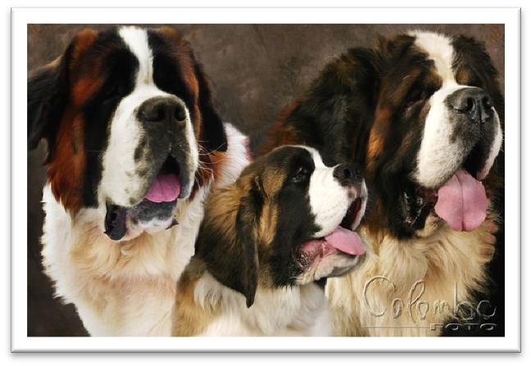

**cross + 宾语 + 方式状语** 表达 用…方式…穿越某个地方

* cross the pass **on foot** （方式状语）
* cross the pass **in cars**

**row across** the Caribbean

* They quickly loaded a small rubber dinghy with food, matches, and tins of beer and **rowed** for a few miles **across** the Caribbean until they arrived at a tiny coral island.

**动词 + across + 宾语**

fly across the English Channel

* In 1908 Lord Northcliffe offered a prize of ￡1000 to the first man who would **fly across the English** Channel.

**cross the pass on foot**

= walk **across** the pass

**cross the pass in cars**

= drive **across** the pass

**row across the Caribbean**

= **cross** the Caribbean by boat

# These friendly dogs, which were first brought from Asia, were used as watchdogs even in Roman times.

environment-friendly adj. 环保的

ozone-friendly adj. 臭氧无害饿

表达“从…引进”

**bring … from …:** 从……带来……

**introduce … from …:** 从……引进……

..., which were introduced from Asia, …

* The grey squirrel was **introduced** into Britain **from** North America.
* In the early days of the settlement of Australia, enterprising settlers unwisely **introduced** the European rabbit.

表达“用作”

**be used as …**

**act / serve / function as …**

同意替换

…, acted / served / functioned as watchdogs even in Roman Times.

# Now that a tunnel has been built through the mountains（原因状语从句）, the Pass is less dangerous, but （并列）each year, the dogs are still sent out into the snow *whenever a traveller is in difficulty*. （让步状语从句）

**now (that)** conj. 同时表示时间和原因

* **Now (that)** you are a big boy you must behave better.

**tunnel** n. 隧道，地道

the Channel Tunnel 海峡隧道

**canal** n. 运河

the Panama Canal 巴拿马运河

**温故：疑问词 + ever 的含义**

**表示“到底……” 引导疑问句。**

* 'Whatever are you doing up here Bill ?' asked the vicar in surprise.

**表示“无论……”引导让步状语从句。**

**= no matter + 疑问词**

* **Wherever** it went, it left behind it a trail of dead deer and small animals like rabbits.
* **No matter where** it went, it left behind it a trail of dead deer and small animals like rabbits.
* …, the dogs are still sent out into the snow **no matter when** a traveller is in difficulty.

**知新**：“疑问词+ever”表示“无论”时还可以用于名词性从句，此时 ≠“no matter+ 疑问词”， 因为后者只能用于让步状语从句。

Whoever wants to sign up for the course (主语从句) is welcome. √

No matter who wants to sign up for the course is welcome. X 缺少主语

No matter who wants to sign up for the course,（让步状语从句） ***he***is welcome. √

Whatever project he works on （主语从句）is always successful.

No matter what project he works on（让步状语从句）, *it* is always successful.

# Despite the new tunnel, there are still a few people who rashly attempt to cross the Pass on foot.

表达“设法、努力做某事”：

**attempt to do sth.**

**try to do sth.**

**make an attempt to do sth.**

**make an effort to do sth.**

**seek to do sth.** (fml. 正规书面语)

* But the historian attempting to reconstruct the distant past is always faced with a difficult task.
* I made an attempt to apologize, but Brian wouldn't even talk to me.
* Over a year passed before the first attempt was made.
* It seems that man was making a real effort to understand the seasons 20,000 years earlier than has been supposed.
* … if, in a word, beauty means something, yet we must not seek to interpret the meaning.

# During the summer months, the monastery is very busy, for it is visited by thousands of people *who cross the Pass in cars*.

**in cars = by car**

表示“使用某种交通工具”的介词短语，“by”后要直接加单数名词； “in”后的名词要有人称和数的变化。

* You can go to the airport in my car.
* We crossed the river in a boat.

# As there are so many people about（adv. 在周围）, the dogs have to be kept in a special enclosure.

As there are so many people about, the dogs have to be …

“独立主格”替换表达：

(With) so many people (being) about, the dogs have to be …

**keep**: confine 把……关起来

* He was kept / confined in prison.
* You shouldn't keep / confine the bird in a cage. life at the monastery

# In winter, however, life at the monastery is quite different.

注意：中文“的”翻译成英文不一定是“of”

life **on** a desert island 在沙漠的

life **in** the army 在军队中

life **on** campus 在校园中

**quite** adv. completely 完全，截然

* The other side of the picture is quite the opposite.
* He used to sleep during the day and work at night, quite unaware of the fact that he had become the ghost of Endley.
* Long car journeys are even less pleasant, for it is quite impossible even to read.
* We live in dread not only of unpleasant insects like spiders or wasps, but of quite harmless ones like moths.
* No two sorts of birds practise quite the same sort of flight; …

# The temperature drops to -30° and very few people attempt to cross the Pass.

表达“下降；

**drops** ***vi.*** 下降；终止

**fall** ***vi.*** 落下；变成；来临；减弱

* The temperature falls to -30°… （与课文替换）
* Little by little the eleven minutes fell to zero.

**plunge** ***vi.*** 突然地下降；投入；陷入；跳进

* The order to abandon ship was given and hundreds of people plunged into the icy water.
* The temperature plunges to -30°… (强调骤降)

**dive to** . (强调骤降)

表达“上升”：

**.. increase to**

**... rise to**

**... rocket to** 暴涨

**... soar to ...** 暴涨

介词“to”表达“到”

The temperature drops **by** 10°. 温度下降**了**10度

表达“温度”：

─30°

**minus** 30 degrees 负30度

30 degrees **below zero** 零下30度

─30°C 摄氏度

minus 30 degrees Centigrade / Celsius

─30°F 华氏度

minus 30 degrees Fahrenheit

# The monks prefer winter to summer for they have more privacy.

**prefer A to B** 更喜欢A不喜欢B

* I prefer mutton to beef. prefer doing to doing

表达”更喜欢A，而不喜欢做B”

**prefer doing to doing**

* I prefer standing to sitting down.
* **托福听力：**

1. She doesn't like to go shopping.
2. She went shopping yesterday.
3. She doesn't live near the shops.
4. She prefers shopping to studying.

W: Didn’t Marian go shopping with you yesterday?

M: Even if she hadn’t had a lot of studying, she would have preferred staying home to going shopping.

Q: What does the man imply about Marian?

Answer: (A) She doesn’t like to go shopping.

**prefer A rather than B**

* I prefer mutton rather than beef.

**prefer to do rather than do**

* I prefer to stand rather than sit down.

**would rather do than do （**两件事都不好，选择一个不太差的）

* I’d rather stand than sit down.
* … people would rather pay large sums of money than have their life work destroyed by gangsters.
* **听力真题：**

1. She wants the man to be at the station when she arrives.
2. She isn’t sure which train she’ll be on.
3. The train will be an hour late.
4. She’ll leave home at 6:30.

M: It says here the next train is due in at 6:30.

W: I know, but I don’t know whether I can make that one. I’d rather call you from the station than have you waiting around for an hour.

Q: What does the woman imply?

Answer: (B) She isn’t sure which train she’ll be on.

# The dogs have greater freedom, too, for they are allowed to wander outside their enclosure.

表达“允许某人做某事”：

**permit sb. to do**

**allow sb. to do**

**give sb. permission to do**

**wander**: to walk aimlessly 漫无目的的闲逛

= roam ***n.*** 漫步，漫游

# The only regular visitors（常客） to the monastery in winter are parties of skiers who go there at Christmas and Easter.

He is one of our restaurant’s regulars. （常客）

What’ll it be?

The usual（口语表达“和往常一样”）, please.

**party** ***n.*** 政党，党派；聚会，派对

a party of tourists

a search party

a rescue party

* After being absent from The Gables for a week, my aunt unexpectedly returned one afternoon with a party of guests （一队客人）and instructed Bessie to prepare dinner.

**group / bunch / crowd / band** 表达“一群人”

* Six hundred years ago, Sir John Hawkwood arrived in Italy with a band of soldiers （一队士兵）and settled near Florence.

**team** 表达一起工作的团队

**gang** 匪帮

**delegation** 一群代表

**galaxy** 一群伟人

* a galaxy of artists / scientists

at Christmas 介词“**at**”表示期间

on Christmas Day 介词“**on**”表示当天

on Easter Day

on weekends 周末 【美】

at weekends 周末 【英】

# These young people, who love the peace of the mountains, always receive a warm welcome at St. Bernard's monastery.

**receive + n.** 受到……; 得到……；遭到……

* …, are always warmly welcomed …. receive a warm welcome

**extend** “致以”

Let’s all **extend** a warm welcome to our visitors.

* No creature has **received** more praise and abuse than the common garden snail.

receive insults 遭到侮辱

receive support 得到支持

receive adequate treatment 得到充分的治疗

receive good education 受到良好教育

* This exhibition received a great deal of attention in the press, … 受到广泛关注